Nama : Adridinan Najmi Faza
NIM : H1D025059
Shift Awal/Akhir : B/H

- Berdasarkan Database order entry dan tabel yang telah dibuat sebelumnya, isikan tabel berikut ini sesuai dengan isian sbb:
a. Tabel customers
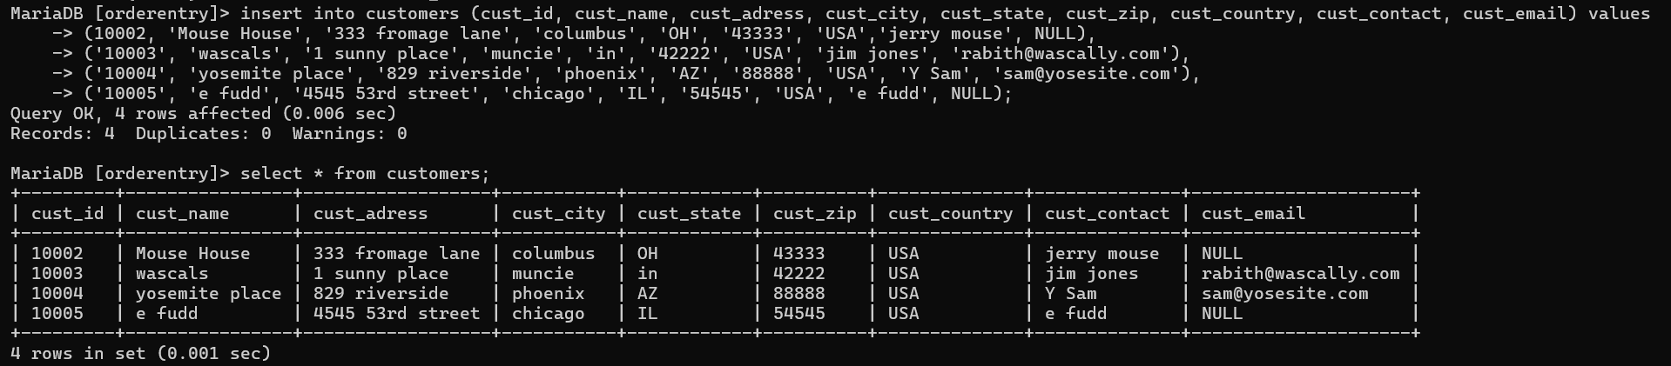
MariaDB [orderentry]> insert into customers (cust_id, cust_name, cust_adress, cust_city, cust_state, cust_zip, cust_country, cust_contact, cust_email) values
-> (10002, 'Mouse House', '333 fromage lane', 'columbus', 'OH', '43333', 'USA','jerry mouse', NULL),
-> ('10003', 'wascals', '1 sunny place', 'muncie', 'in', '42222', 'USA', 'jim jones', 'rabith@wascally.com'),
-> ('10004', 'yosemite place', '829 riverside', 'phoenix', 'AZ', '88888', 'USA', 'Y Sam', 'sam@yosesite.com'),
-> ('10005', 'e fudd', '4545 53rd street', 'chicago', 'IL', '54545', 'USA', 'e fudd', NULL);
Query OK, 4 rows affected (0.006 sec)
Records: 4 Duplicates: 0 Warnings: 0

b. Tabel product
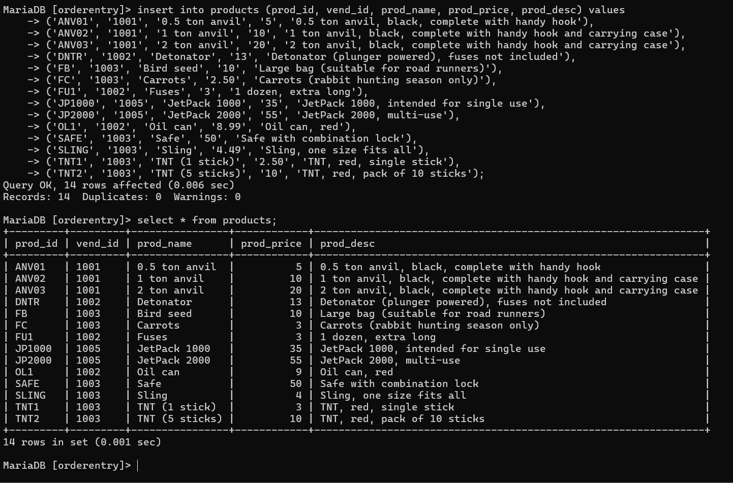

MariaDB [orderentry]> insert into products (prod_id, vend_id, prod_name, prod_price, prod_desc) values
-> ('ANV01', '1001', '0.5 ton anvil', '5', '0.5 ton anvil, black, complete with handy hook'),
-> ('ANV02', '1001', '1 ton anvil', '10', '1 ton anvil, black, complete with handy hook and carrying case'),
-> ('ANV03', '1001', '2 ton anvil', '20', '2 ton anvil, black, complete with handy hook and carrying case'),
-> ('DNTR', '1002', 'Detonator', '13', 'Detonator (plunger powered), fuses not included'),
-> ('FB', '1003', 'Bird seed', '10', 'Large bag (suitable for road runners)'),
-> ('FC', '1003', 'Carrots', '2.50', 'Carrots (rabbit hunting season only)'),
-> ('FU1', '1002', 'Fuses', '3', '1 dozen, extra long'),
-> ('JP1000', '1005', 'JetPack 1000', '35', 'JetPack 1000, intended for single use'),
-> ('JP2000', '1005', 'JetPack 2000', '55', 'JetPack 2000, multi-use'),
-> ('OL1', '1002', 'Oil can', '8.99', 'Oil can, red'),
-> ('SAFE', '1003', 'Safe', '50', 'Safe with combination lock'),
-> ('SLING', '1003', 'Sling', '4.49', 'Sling, one size fits all'),
-> ('TNT1', '1003', 'TNT (1 stick)', '2.50', 'TNT, red, single stick'),
-> ('TNT2', '1003', 'TNT (5 sticks)', '10', 'TNT, red, pack of 10 sticks');
Query OK, 14 rows affected (0.006 sec)
Records: 14 Duplicates: 0 Warnings: 0

c. Tabel vendors
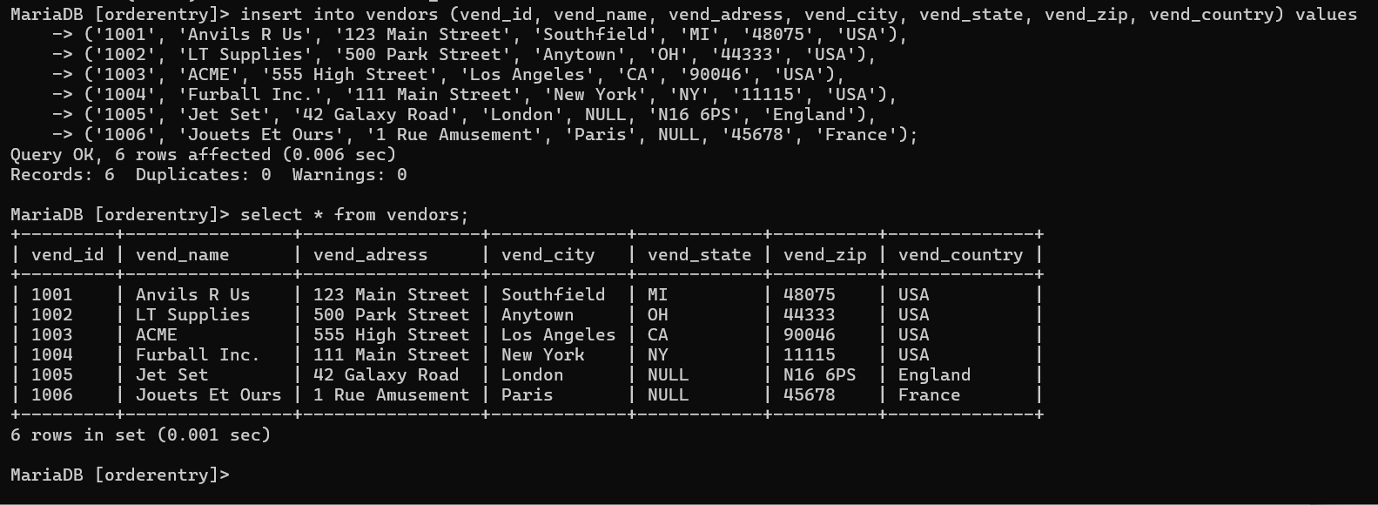
insert into vendors (vend_id, vend_name, vend_adress, vend_city, vend_state, vend_zip, vend_country) values
('1001', 'Anvils R Us', '123 Main Street', 'Southfield', 'MI', '48075', 'USA'),
('1002', 'LT Supplies', '500 Park Street', 'Anytown', 'OH', '44333', 'USA'),
('1003', 'ACME', '555 High Street', 'Los Angeles', 'CA', '90046', 'USA'),
('1004', 'Furball Inc.', '111 Main Street', 'New York', 'NY', '11115', 'USA'),
('1005', 'Jet Set', '42 Galaxy Road', 'London', NULL, 'N16 6PS', 'England'),
('1006', 'Jouets Et Ours', '1 Rue Amusement', 'Paris', NULL, '45678', 'France');

d. Tabel orderitems
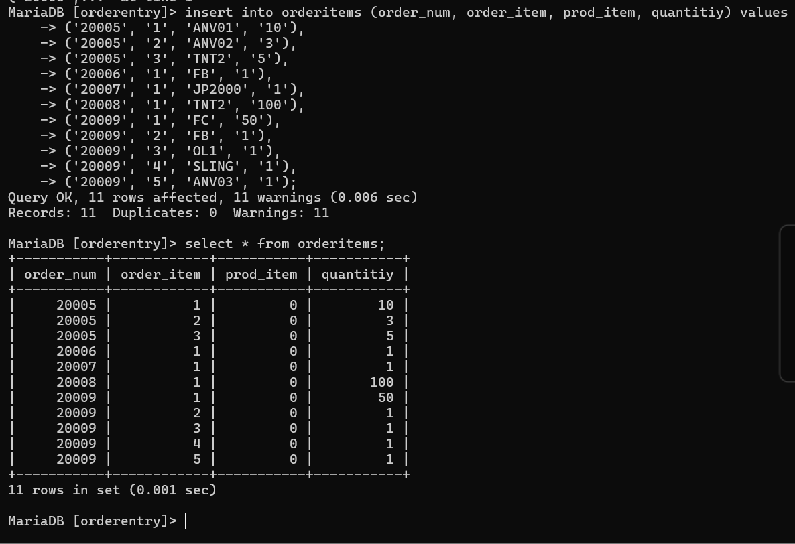
INSERT INTO orderitems (order_num, order_item, prod_item, quantitiy) VALUES
('20005', '1', 'ANV01', '10'),
('20005', '2', 'ANV02', '3'),
('20005', '3', 'TNT2', '5'),
('20006', '1', 'FB', '1'),
('20007', '1', 'JP2000', '1'),
('20008', '1', 'TNT2', '100'),
('20009', '1', 'FC', '50'),
('20009', '2', 'FB', '1'),
('20009', '3', 'OL1', '1'),
('20009', '4', 'SLING', '1'),
('20009', '5', 'ANVB3', '1');

- Setelah keempat table diisi tampilakan query berikut ini
a. Ubahlah data salah satu customer dengan perintah update
BEFORE
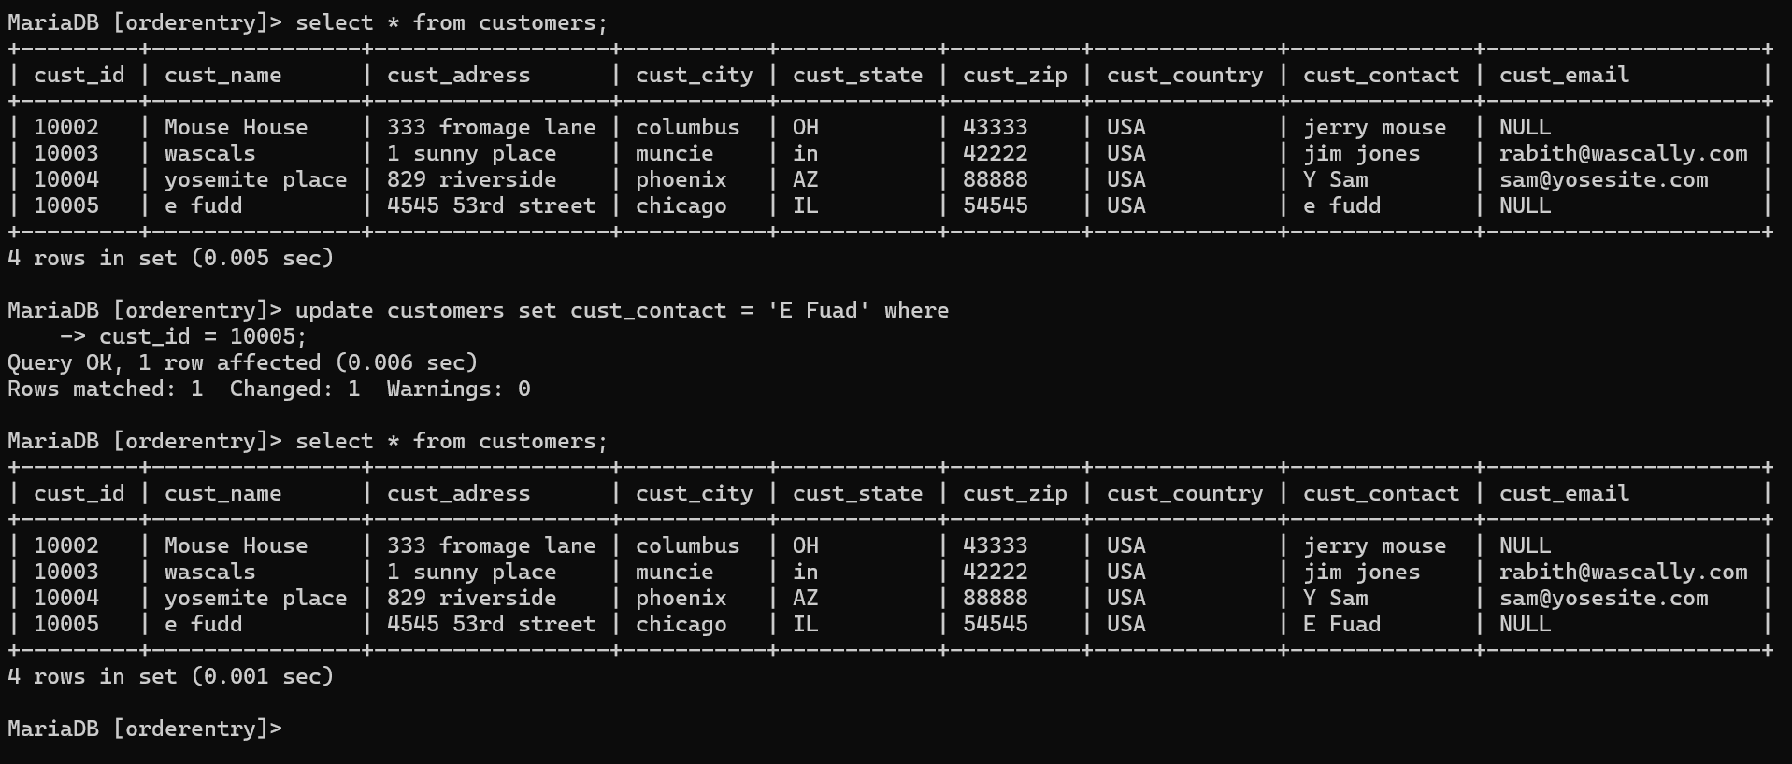
AFTER
Syntax:
update customers set cust_contact = 'E Fuad' where cust_id = 10005;
b.Hapuslah data salah satu vendor atau product dengan perintah delete
BEFORE
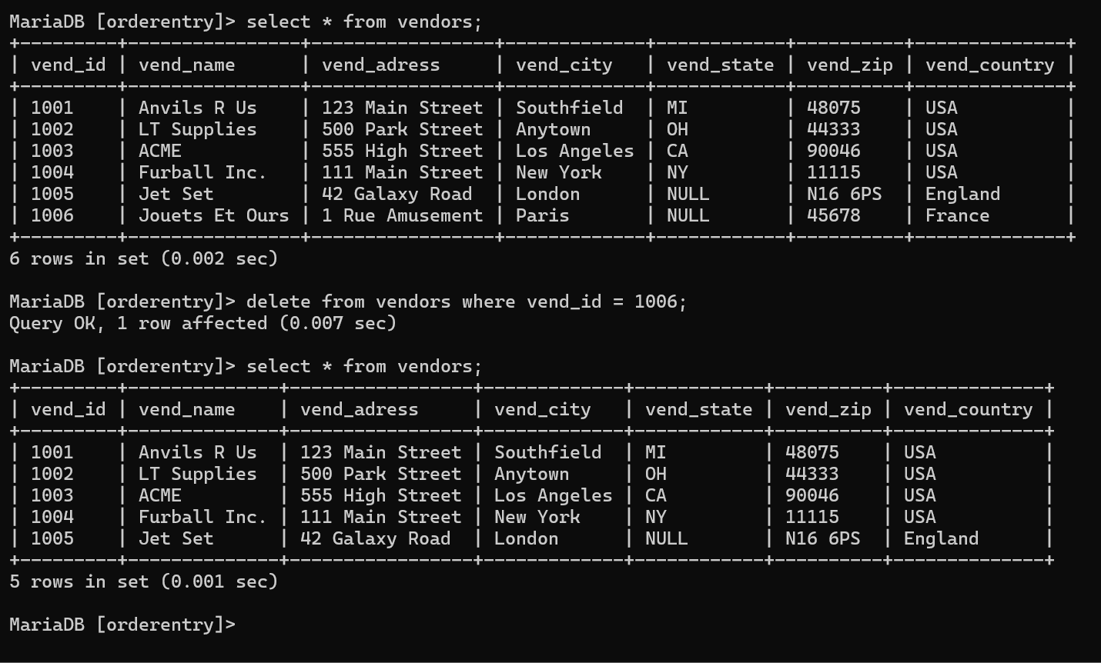
AFTER
Syntax:
delete from vendors where vend_id = 1006;
c.Tampilkan nomer order dan jumlahnya
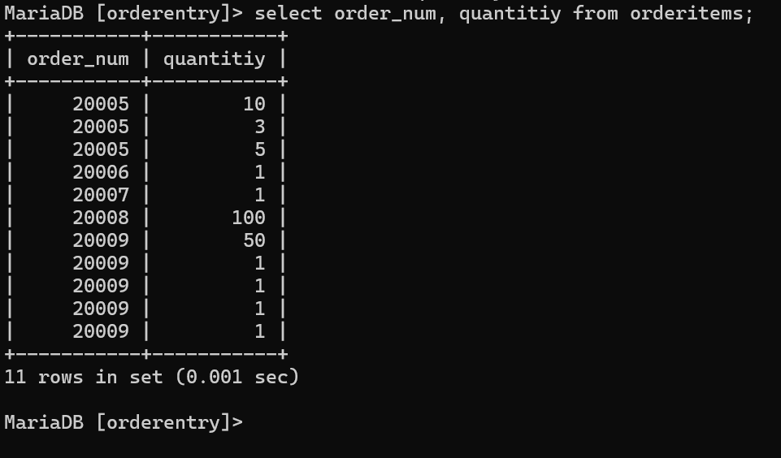
Syntax:
select order_num,quantity from orderitems;
d.Tampilkan data customer yang berasal dari “USA’’
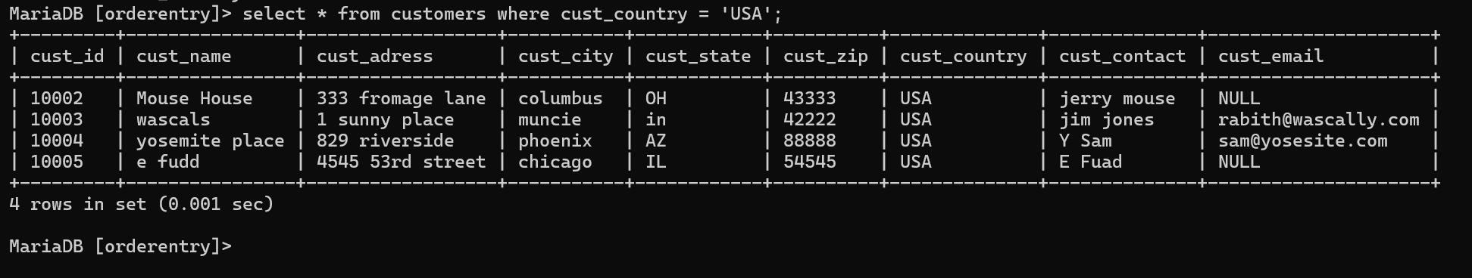
Syntax:
select * from customers where cust_country = 'USA';

